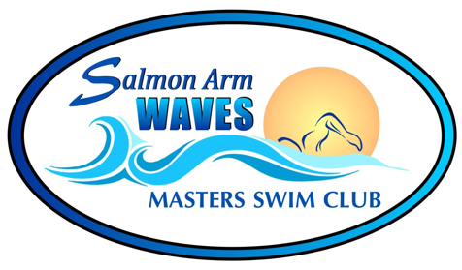
Spring 2025 Registration

Last Name: __________________________________ First Name: ______________________________________
Mailing Address: _________________________________________________________________________________
Postal Code: ________________________ E-mail: ____________________________________
Home Phone #: ________________________________ Work Phone #: _____________________________________
Sex: M / F Date of Birth: _______________________

Have you previously swum with another Masters Club? If YES, CLUB: __________________ Year:__________

ALL MEMBERS AND POTENTIAL MEMBERS SWIMMING WITH THE SALMON ARM WAVES MASTERS SWIM CLUB ARE
REQUIRED TO COMPLETE THIS FORM, AND THE MEDICAL INFO/EMERGENCY CONTACT SHEET,
AND COMPLETE YOUR REGISTRATION ON THE SWIM BC PLATFORM
Swim Season Spring Session: April 22 to June 30, 2025
Available Times:
Monday (4 lanes) | Tuesday (3 lanes) | Wednesday (4 lanes) | Thursday (3 lanes) | Saturday (3 lanes)
7:30-9:00 pm | 6:00-7:30 am | 7:30-9:00 pm | 6:00-7:30 am | 6:45 – 8:15 am

Session Fees: (10-week session) ***SPECIAL REDUCED RATE THIS SESSION ONLY***
1x/week: $130 $105.00 2x/week: $185 $150.00 3x/week: $225 $180.00
PLUS $64 MSABC Fee. The MSABC fee ($64) is mandatory to cover MSABC insurance. This is paid once per year. Fees are due by April 30th, 2025.
Fees must be paid as a lump sum via e-transfer. e-transfer - salmonarmmasters@gmail.com
Please print and scan Registration Form and Emergency contact forms to registrar@salmonarmwaves.ca

The Swim Club has formed a NO REFUND POLICY concerning swimming fees for those registered with our program. Our financial commitments involve annual contracts, pool fees and lifeguard fees. The Swim Club is obligated to fulfill these contracts regardless of the number of swimmers we have in the water at any time. Understandably many of our swimmers will experience, at some time during the season, illness or injury. While we regret these problems, a refund will only be considered if a swimmer can no longer participate for greater than 4 weeks. A physician’s note may be required. Travel / vacation will not be considered for a refund.
NO Swims: Monday May 19th May Long Weekend
Saturday June 21st Sockeyes Swim Meet

NOTE: Returning Swimmers: Please email registrar with # days/week you are registering for. This form is not required.

