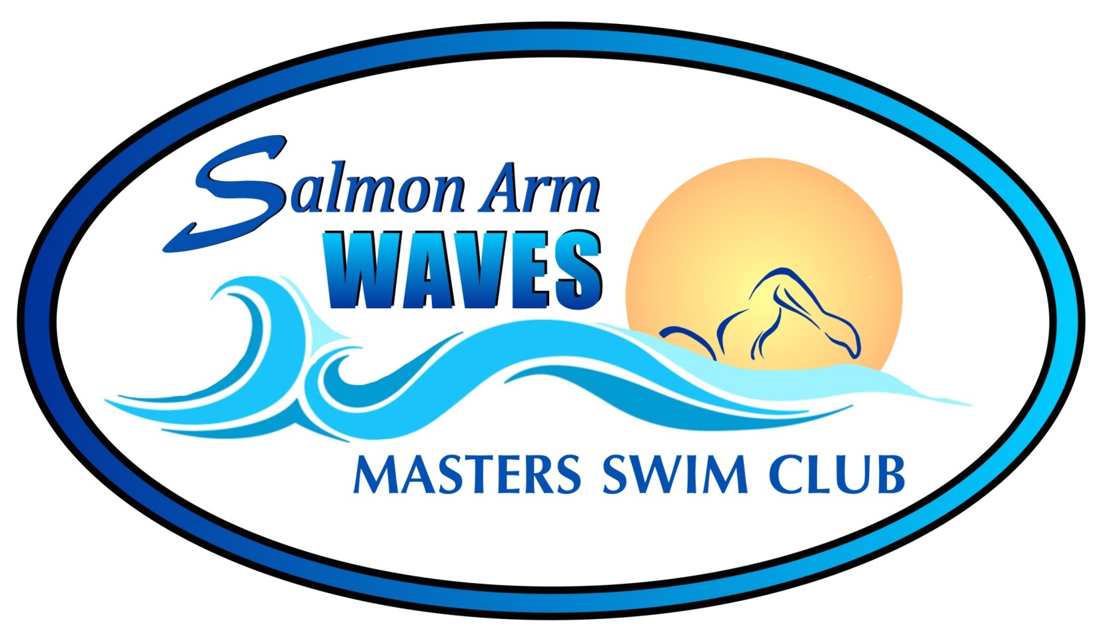

**Spring 2023 Registration**

Last Name: __________________________________ First Name: ______________________________________

Mailing Address: _________________________________________________________________________________

Postal Code: ________________________ E-mail: ____________________________________

Home Phone#: ________________________________ Work Phone #: _____________________________________

Sex: M / F Date of Birth: _______________________

ALL MEMBERS AND POTENTIAL MEMBERS SWIMMING WITH THE **SALMON ARM WAVES MASTERS SWIM CLUB** ARE

REQUIRED TO COMPLETE AND SIGN THE MSABC WAIVER FORM, THE SWIM BC ASSUMPTION OF RISK FORM, AND THE MEDICAL INFO/EMERGENCY CONTACT SHEET

**Swim Season Spring Session: April 11th to June 22nd 2023**

**Available Times: (Please circle the Days that you intend to be swimming on)**

|  |  |  |  |  |
| --- | --- | --- | --- | --- |
| Monday (4 lanes) | Tuesday (3 lanes) | Wednesday (4 lanes) | Thursday (3 lanes) | Saturday (3 lanes) |
| 7:30-9:00 pm | 6:00-7:30 am | 7:30-9:00 pm | 6:00-7:30 am | 6:45 – 8:15 am |

**Session Fees: (11-week session) - No swimming on Stat Days or Saturdays of Stat Weekends**

1x/week: $135.00 2x/week: $200.00 3x/week: $240.00 PLUS $49 MSABC Fee

**The MSABC fee ($49) is mandatory to cover MSABC insurance. This is paid once per year.**

I confirm that I am fully vaccinated with COVID-19 vaccines ___ YES ___ NO ____________

(Proof to be emailed to registrar@salmonarmwaves.ca) Initials

Fees must be paid as a lump sum via e-transfer. e-transfer - [salmonarmmasters@gmail.com](mailto:salmonarmmasters@gmail.com). Password=swimming. Fees are due by April 15th 2023

Please print and scan Registration & Emergency contact forms to **registrar@salmonarmwaves.ca**

***The Swim Club has formed a NO REFUND POLICY concerning swimming fees for those registered with our program.***  Our financial commitments involve annual contracts, pool fees and lifeguard fees. The Swim Club is obligated to fulfill these contracts regardless of the number of swimmers we have in the water at any time. Understandably many of our swimmers will experience, at some time during the season, illness or injury. While we regret these problems, a refund will only be considered if a swimmer can no longer participate for greater than 4 weeks. A physician’s note will be required. Travel / vacation will not be considered for a refund.

**NO** Swims: Monday April 10th (Easter Monday)

Saturday May 20th and Monday May 22nd (May long weekend)

Saturday June 24th (Sockeye’s Swim Meet – so ending the session June 22)